Supplementary Material Table 1 Exact test probabilities of homogenous allele frequencies between pairs of colonies.
 | Penguin Island | Cheyne Island | Pearson Island | Spencer Gulf | Troubridge Island | Kingscote | Penneshaw | West Island | Granite Island | Middle Island | London Bridge | Phillip Island | Gabo Island | Lillico Beach | Bruny Island | Lion Island | Cabbage Tree Island
Penguin Island |  | <0.001¹ | <0.001¹ | 0.001¹ | <0.001¹ | <0.001¹ | <0.001¹ | 0.001 | <0.001¹ | 0.397 | 0.003¹ | 0.003¹ | 0.122 | 0.059 | 0.129 | 0.260 | 0.008¹
Cheyne Island | <0.001¹ |  | 0.013 | 0.071 | <0.001¹ | <0.001¹ | 0.022 | <0.001¹ | 0.009¹ | <0.001¹ | <0.001¹ | <0.001¹ | <0.001¹ | <0.001¹ | <0.001¹ | <0.001¹ | <0.001¹
Pearson Island | <0.001¹ | <0.001¹ |  | 0.087 | <0.001¹ | <0.001¹ | 0.010 | <0.001¹ | 0.010 | <0.001¹ | <0.001¹ | <0.001¹ | <0.001¹ | <0.001¹ | <0.001¹ | 0.001¹ | <0.001¹
Spencer Gulf | <0.001¹ | <0.001¹ | 0.006¹ |  | <0.001¹ | 0.373 | 0.336 | 0.021 | 0.044 | <0.001¹ | <0.001¹ | <0.001¹ | <0.001¹ | <0.001¹ | <0.001¹ | 0.022 | <0.001¹
Troubridge Island | <0.001¹ | <0.001¹ | <0.001¹ | 0.075 |  | <0.001¹ | <0.001¹ | <0.001¹ | <0.001¹ | <0.001¹ | <0.001¹ | <0.001¹ | <0.001¹ | <0.001¹ | <0.001¹ | <0.001¹ | <0.001¹
Kingscote | <0.001¹ | <0.001¹ | <0.001¹ | 0.015 | <0.001¹ |  | 0.044 | <0.001¹ | <0.001¹ | <0.001¹ | <0.001¹ | <0.001¹ | <0.001¹ | <0.001¹ | <0.001¹ | <0.001¹ | <0.001¹
Penneshaw | <0.001¹ | <0.001¹ | <0.001¹ | 0.007¹ | <0.001¹ | <0.001¹ |  | 0.001¹ | 0.007¹ | <0.001¹ | <0.001¹ | <0.001¹ | <0.001¹ | <0.001¹ | <0.001¹ | <0.001¹ | <0.001¹
West Island | <0.001¹ | <0.001¹ | <0.001¹ | 0.001¹ | <0.001¹ | <0.001¹ | <0.001¹ |  | 0.012 | 0.004¹ | <0.001¹ | 0.007¹ | 0.004¹ | 0.001¹ | 0.023 | 0.090 | <0.001¹
Granite Island | <0.001¹ | <0.001¹ | <0.001¹ | 0.004¹ | <0.001¹ | <0.001¹ | <0.001¹ | 0.414 |  | <0.001¹ | <0.001¹ | <0.001¹ | <0.001¹ | 0.001¹ | 0.002¹ | 0.046 | <0.001¹
Middle Island | <0.001¹ | <0.001¹ | <0.001¹ | <0.001¹ | <0.001¹ | <0.001¹ | <0.001¹ | 0.005¹ | 0.023 |  | 0.039 | 0.015 | 0.906 | 0.511 | 0.392 | 0.371 | 0.025
London Bridge | <0.001¹ | <0.001¹ | <0.001¹ | <0.001¹ | <0.001¹ | <0.001¹ | <0.001¹ | <0.001¹ | <0.001¹ | 0.616 |  | 0.367 | 0.058 | 0.425 | 0.063 | 0.033 | <0.001¹
Phillip Island | <0.001¹ | <0.001¹ | <0.001¹ | 0.002¹ | <0.001¹ | <0.001¹ | <0.001¹ | 0.001¹ | <0.001¹ | 0.148 | 0.222 |  | 0.068 | 0.089 | 0.025 | 0.143 | 0.005¹
Gabo Island | <0.001¹ | <0.001¹ | <0.001¹ | <0.001¹ | <0.001¹ | <0.001¹ | <0.001¹ | <0.001¹ | <0.001¹ | 0.015 | 0.165 | 0.002 |  | 0.632 | 0.346 | 0.274 | 0.082
Lillico Beach | <0.001¹ | <0.001¹ | <0.001¹ | <0.001¹ | <0.001¹ | <0.001¹ | <0.001¹ | 0.004¹ | 0.005¹ | 0.681 | 0.109 | 0.042 | 0.418 |  | 0.432 | 0.376 | <0.001¹
Bruny Island | <0.001¹ | <0.001¹ | <0.001¹ | 0.001¹ | <0.001¹ | <0.001¹ | <0.001¹ | 0.014 | 0.152 | 0.765 | 0.733 | 0.725 | 0.901 | 0.989 |  | 0.502 | 0.009¹
Lion Island | <0.001¹ | <0.001¹ | <0.001¹ | 0.001¹ | <0.001¹ | <0.001¹ | <0.001¹ | 0.007¹ | 0.018 | <0.001¹ | <0.001¹ | 0.006¹ | 0.017 | 0.017 | 0.023 |  | 0.039
Cabbage Tree Island | <0.001¹ | <0.001¹ | <0.001¹ | <0.001¹ | <0.001¹ | <0.001¹ | <0.001¹ | <0.001¹ | <0.001¹ | <0.001¹ | <0.001¹ | <0.001¹ | 0.001¹ | <0.001¹ | 0.012 | <0.001¹
Microsatellite loci below the diagonal, mitochondrial DNA above the diagonal.¹Significant following Benjamini-Yekutieli correction.

Supplementary Material Figure 1Delta Kand mean LnP(K) as a function of K (number of inferred clusters) during STRUCTURE analysis. Error bars represent standard deviation.

Supplementary Material Figure 2 Estimated individual coancestry proportions from STRUCTURE analysis, assuming 2–6 clusters. Each individual is represented by a vertical bar with colours proportional to its estimated coancestry to each cluster. The source of individuals is demarcated along the bottom of the chart.

Supplementary Figure 3 Cline in first axis scores from multiple correspondence analysis of mitochondrial DNA haplotype frequencies, along a transect spanning southern Australian colonies of Eudyptula minor (from Cheyne Island to Gabo Island). The fill of each individual data point was 97% transparent, such that final shading provides an indication of the frequencies of haplotypes with a given score within each colony. Line represents the maximum likelihoodfit of a sigmoidal curve.

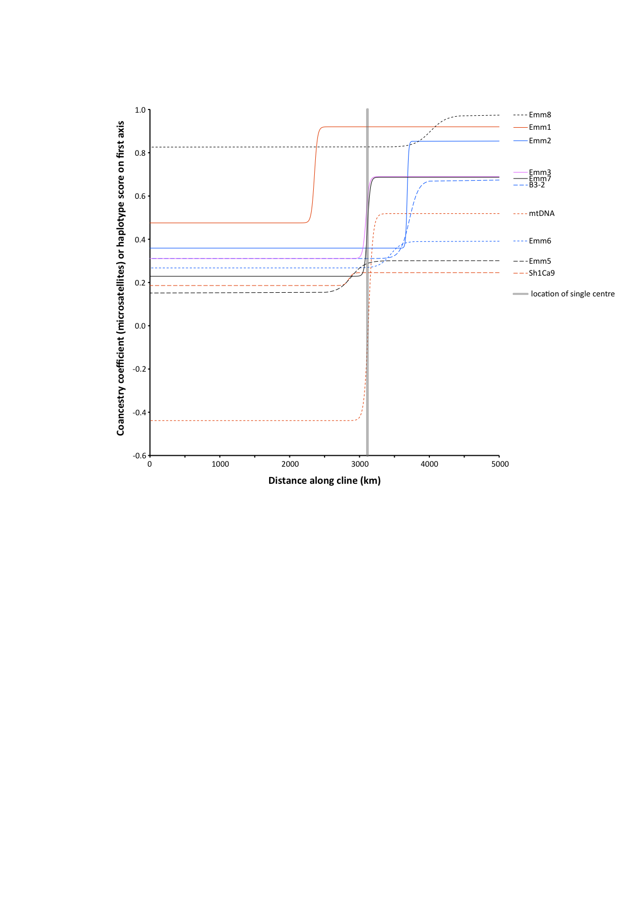
Supplementary Figure 4 Cline in coancestry coefficients from STRUCTURE analysis of microsatellite loci analysed individually, and first axis scores from multiple correspondence analysis of mitochondrial DNA haplotype frequencies, along a transect spanning southern Australian colonies of Eudyptula minor (from Cheyne Island to Gabo Island). The grey vertical line indicates the position of cline centre when all loci are constrained to the same location.

